**HOMEWORK ASSIGNMENT #5**

**Please complete the following items from Chapter 5 and submit by the assigned due date.**

**Algorithm Workbench *(2 pts each)***

**3.** Design a For loop that displays the following set of numbers:

0, 10,20,30,40,50 ... 1000\

Declare Integer counter

Constant Integer maximum = 1000

Set counter = 0

For counter = 0 to maximum Step 10

Display counter

End For

**10.** Convert the following For loop to a While loop:

Declare Integer count

For count= 1 To 50

Display count

End For

Declare Integer count

While count =< 50

Display count

count = count + 1

End While

**Debugging Exercises: *(2 pts each)***

**1.** Find the error in the following pseudocode.

Declare Boolean finished = False

Declare Integer value, cube

While NOT finished

Display "Enter a value to be cubed. "

Input value

Set cube= value^3

Display value, " cubed is ", cube

End While

This either needs to be a do while loop so that it iterates once and once only, or needs to have an expression which changes the state of the Boolean variable “finished.” In its current state, the program will simply loop infinitely.

**2.** The programmer intended the following pseudocode to display the numbers 1 through 60, and then display the message "Time's up!" It will not function as intended, however. Find the error.

Declare Integer counter=1

Const Integer TIME LIMIT= 60

While counter< TIME LIMIT

Display counter

Set counter= counter+ 1

End While

Display "Time's up! "

There error is that his counter statement only performs as counter<TIMELIMIT which means that once the time hits 60, 60 will not be displayed, as 60 is not less than 60. This program will only count to 59 then will display “Time’s up!”

**Programming Exercises: *(5 pts pseudocode, 5 pts flowchart, 7 pts Python code)***

**8.** **Celsius to Fahrenheit Table**

Design a program that displays a table of the Celsius temperatures 0 through 20 and their Fahrenheit equivalents. The formula for converting a temperature from Celsius to Fahrenheit is:

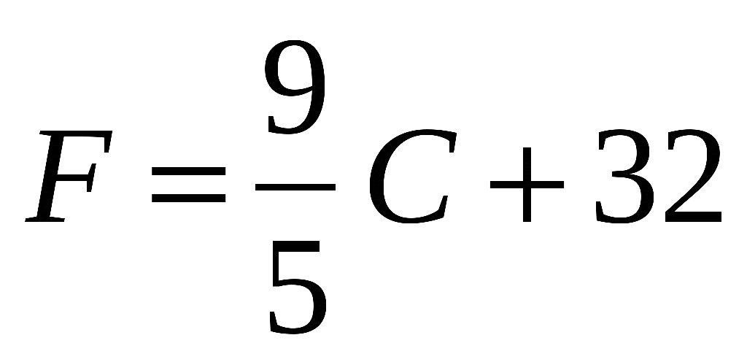

You must complete the pseudocode, flowchart and python 3 code for this assignment.

***The Raptor flowchart and Python code must be uploaded separately (your .rap file and your .py file), along with another document containing the answers to Algorithm Workbench and Debugging Exercise items.***

***NOTE: These items are copied directly from your textbook. I would rely on the problem listed in the textbook, rather than what is in this document, as sometimes the text does not copy over correctly.***

Pseudocode on next page

Start

Declare Integer tempC = 0

Declare Real tempF = 0

Declare String tab = “ “

Declare String tab2 =” “

Declare String tab3 =” “

Call displayModule

Call tempChanger

//-------------------------------------------------------

Start Module displayModule

Display “Celsius”, tab3, “Fehrenheit”)

Display “--------------------------“

End Module

//------------------------------------------------------

Start Module tempChanger

Declare Integer maxTemp = 20

While tempC <= maxTemp

tempF = tempC * 9/5 + 32

if tempC < 10

Display tempC, tab, tempF

Else

Display tempC, tab2, tempF

End If

tempC = tempC + 1

End While

End Module